Ninian Beall Sr.
Born 1625, Lower Largo, Fife, Scotland
Died 1717, Prince George’s County, Maryland
Information found on findagrave.com

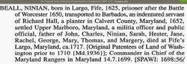

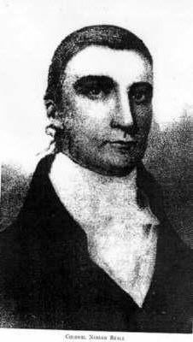

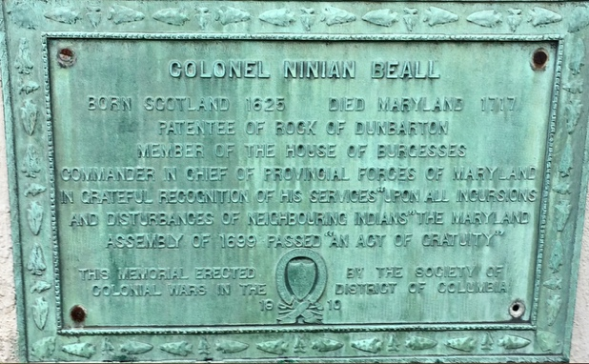

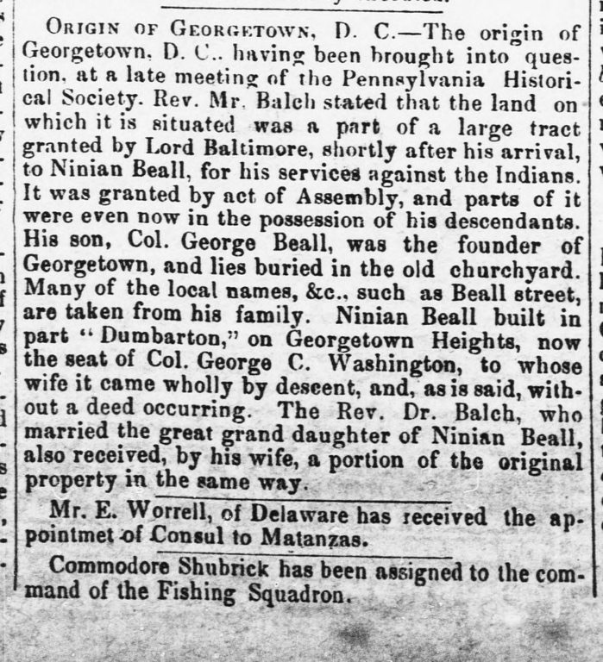

Ninian Beall, b. in Largo, Fifeshire, Scotland, in 1625. His will is dated 15th Jan. 1717 and was probated 28th Feb. 1717. He held a commission as cornet in the Scotch-English Army, raised to resist Cromwell. He fought in the battle of Dunbar, 3d. Sept. 1650, against Cromwell. He was made prisoner at that battle and sentenced to five years' servitude. He was sent with 150 other Scotchmen to Barbadoes, West Indies. About 1652 they appeared in the Province of Maryland. Ninian Beall served his five years with Richard Hall, a planter of Calvert Co.

In Liber 5, folio 416, Maryland Land Office Records of 1658, there is a record of Ninian Beall making a land transfer in Calvert Co., Md. It seems that these military prisoners were entitled to 50 acres of public land after completing service. In Liber 11, folio 195, Maryland Land Office has the following 16th Jan. 1667: "Then came Ninian Beall of Calvert County, Planter and proved right to 50 acres of land for his time service performed with Richard Hall of same county." By the inexperienced reader the servitude of Col. Ninian Beall for five years under Richard Hall, on account of fighting against Cromwell, may be rated as a disgrace. This humiliation of servitude which came to him not on account of crime, but through the fortunes of war, was an honor. The principle for which he fought finally triumphed in the overthrow of Cromwell. His servitude was a halo of martyrdom for a principle which was honorable. Although he had many chances to escape from servitude after reaching Maryland, yet we find the instincts of a gentleman and soldier prompted him to not only honorably and gracefully submit to the fortunes of war, but at the same time, by so doing, he gained the respect and confidence of the people of Maryland to such a degree that they showered continuous honors upon him to the day of his death.

Ninian Beall's military ability in the Scotch-English Army seems to have been made good use of in the Province of Maryland, as shown by the following notations:
1668: Records at Annapolis, dated 31st Oct. 1668, call him Lieut. Ninian Beall.
1676: Commissioned Lieut. of Lord Baltimore's "Yacht of War, Loyal Charles of Maryland, John Goade Commander."
1684: Deputy Surveyor of Charles Co.
1688: Appointed Chief Military Officer of Calvert Co.
1692: Appointed High Sheriff of Calvert Co.
1694: Appointed Colonel of Militia by the Assembly 30th July 1694.
1697: Appointed on a Commission by the Assembly to treat with the Indians.
1679–1701: Was a member of the General Assembly.
1699: The General Assembly passed an "Act of Gratitude" for "the distinguished Indian services of Colonel Ninian Beall." (See Liber LL No. 11, folio 228, Archives of Maryland.)

Col. Ninian Beall's signal defeat and destruction of the great Susquehannah Tribe of Indians caused him to be recognized as an Indian fighter of ability. Many official papers written by Col. Ninian Beall and on file in the Provincial Records show that he was a man of broad experience, great mental capacity, undoubted integrity, perfect moral courage and of good education. His signatures to official papers are bold and free. As he signed his will by witnessed mark, that would indicate that he must have been in a very feeble condition of body at the time for he was 92 years old. He figures in many land transfers. It is estimated that he owned about 4000 acres. There has been much speculation as to whether Col. Ninian Beall's family name in Scotland was spelled BEALL or BELL. Official papers in Maryland records are signed by him in a variety of ways; namely, Ninian BALE, Ringing BELL, Ninian BEALE, Ninion BEALE, Ninian BELL and Ninian BEALL. After 1667 he signed everything as Ninian BEALL.

He seems to have identified himself with the Presbyterian Church of Maryland before 1690. During that year 200 Presbyterian immigrants came over from Scotland under his supervision. He located them along the Potomac River and called the settlement New Scotland. These immigrants brought with them Rev. Nathaniel Taylor. There is recorded at Upper Marlboro a deed of gift from Col. Ninian Beall to Reverend Taylor, of land in Upper Marlboro upon which to build a church. In 1707 Col. Ninian Beall presented the above church a costly silver communion set, made in London. A portion of this silver communion set is now in the Presbyterian Church at Hyattsville, Md.

Col. Ninian Beall had three brothers who settled in the Province of Maryland; namely, Thomas, John and George. Their descendants are numerous. He m. about 1670, Ruth Moore, dau. of Richard and Jane Moore, Barrister of St. Mary's Co., Md. He d. in 1717. He was bur. on his Rock of Dumbarton Plantation, at a point now Gay Street, Georgetown, D.C. When his body was removed, his skeleton was found to be perfect, and measured six feet seven inches and his hair had grown long and retained its youthful color of red.

[Written by George Norbury Mackenzie, 1907, "Colonial Families of the United States," vol. 2, pp. 66-68]

